



Assignment Title:
Dynamic Robotics Simulation and Autonomous System Design
Programme title:
MSc Artificial Intelligence
Prepared by:
Amaan Mohammed Khalander
Module:
Robotics Software and Programming
Year:
Term 2 – 2026
Submission Date:
23 / September / 2026
Issued by:
Dr Fahmid Al Farid

Learner declaration
Item | Response
Word count | IN END
Use of proof-reader/proof-reading service | NO
If yes, specify which service | N/A
I confirm that I submit this work as my own work and have cited all sources used | YES
I confirm that I have followed guidance on the acceptable use of AI tools for this assignment | YES
Where use of appropriately cited AI tools is permitted, I confirm that I have cited in accordance with the UCA Harvard Referencing Standard | YES

Student signature | Date
 | 23 / September / 2026

Source Code and Relevant Project Links:
Source Code:
- Task 1:
https://github.com/Amaan9136
- Task 2:
https://github.com/Amaan9136

Table of Contents
Abstract 6
Introduction 7
Task 1: Interactive PyBullet Environment with Object Semantics 8
3.1 Project Definition 8
3.2 Literature Review 8
3.3 Design and Implementation 8
3.4 Code Implementation 10
3.5 Execution and Testing 10
3.6 Evaluation and Reflection 11
Task 2: Goal-Oriented Autonomous Robot with Monitoring (ROS2) 13
4.1 Project Definition 13
4.2 Design and Implementation 14
4.3 Execution and Testing 16
4.4 Evaluation and Reflection 20
Combined Evaluation and Reflection 22
Concluding Remarks 23
Acknowledgement 24
References 25

Table of Figures
Figure 1: Six PyBullet camera viewpoints, robot repositioned between renders while all other objects remain fixed. 11
Figure 2: TheConstruct.ai Rosject XctZpczWOA: file explorer, mission_controller.py in the code editor, the live Simulation panel, and monitor_node’s summary stream in the shell. 16
Figure 3: Gazebo client mid-patrol on TheConstruct.ai: robot among the eight pallet obstacles and checkpoint markers, with elapsed real time and iteration count visible. 17
Figure 4: keyboard_hri_node in a Rosject shell: start and pause keypresses published and confirmed, alongside the live Simulation panel. 17
Figure 5: Live /mission_state echo showing the robot cycle through AVOID_OBSTACLE, REPLAN, IDLE, PLANNING, NAVIGATE and MISSION_COMPLETE. 18
Figure 6: monitor_node’s mission summary, captured shortly before MISSION_COMPLETE. 19
Figure 7: Local Gazebo Harmonic verification: LIDAR rays visualised around the robot near a pallet obstacle, with the forward camera feed shown alongside. 20
List of Tables
Table 1: Final training epochs 12
Table 2: Final validation performance (Task 1) 13
Table 3: Offline verification summary 19
Table 4: Live ROSject verification (ros2 topic echo, single query each, shown in Figure 7) 20

Statement of compliance with academic ethics and the avoidance of plagiarism
I honestly declare that this dissertation is entirely my own work, and that none of its parts has been copied from printed or electronic sources, translated from foreign sources, or reproduced from essays by other researchers or students. Wherever I have based my work on ideas or other people's texts, I clearly declare it through proper references in line with academic ethics.

(In the case that is proved that part of the essay does not constitute an original work, but a copy of an already published essay or from another source, the student will be expelled permanently from the postgraduate program).

Name and Surname:
AMAAN MOHAMMED KHALANDER
Date: 23 / September / 2026

Abstract
This report documents two practical exercises completed for the Robotics Software and Programming module, under the assignment brief Dynamic Robotics Simulation and Autonomous System Design. Task 1 builds a semantically labelled PyBullet simulation of a small inspection and light-warehousing room, using five custom URDF object categories, a two-wheel robot, fourteen placed object instances, six camera viewpoints, and a Python dictionary-based semantic registry supporting role lookup and nearest-target queries. Task 2 implements a six-state finite state machine for a TurtleBot3 in ROS2, running in a custom Gazebo warehouse world with eight pallet obstacles, four patrol checkpoints and a charging dock, adding path planning, LIDAR and odometry based obstacle avoidance, a keyboard human-robot interaction node, and a monitoring node that logs state transitions and mission metrics. Task 2 was developed and run to completion on TheConstruct.ai, the platform the brief specifies, inside Rosject XctZpczWOA, with a local ROS2 Jazzy and Gazebo Harmonic workspace used only as a supplementary aid for inspecting LIDAR and camera visualisation. Both systems were executed, and the resulting console output, logs and renders form the evidence base for this report. Together, the two tasks trace one thread: representing what objects and behaviours mean, first as static metadata attached to a scene, then as a state machine reasoning about sensor data in real time.

Introduction
The Robotics Software and Programming module asks students to design, build and evaluate robotic software entirely within simulation, so the resulting skills transfer to hardware without requiring access to it. The brief, Dynamic Robotics Simulation and Autonomous System Design, sets out two stages of increasing complexity: an interactive PyBullet environment with object-level semantics, and a ROS2-based autonomous system with sensing, navigation, human interaction and self-monitoring. The stages use different toolchains, but the submission guidelines require one consolidated report, so both are presented together here using the official BSBI template.
Task 1 treats a simulated room as more than geometry: every object is assigned a role, obstacle, target, landmark, shelf or charger, stored so it can be queried in code rather than inferred visually. Task 2 carries the same idea into a dynamic setting, where a mobile robot reads LIDAR and odometry in real time, chooses between a discrete set of behavioural states, and reports on what it did and why. Together, the two tasks move from a static scene with designer-assigned semantics towards a robot whose own behavioural categories, navigating, avoiding, replanning, are a semantic label it applies to itself. That progression, from meaning attached to objects to meaning attached to behaviour, is the thread running through this report.

Task 1: Interactive PyBullet Environment with Object Semantics

3.1 Project Definition
The objective of Task 1 was a structured, semantically meaningful PyBullet scene in which the roles of objects, not just their geometry, could be queried programmatically. Before any code was written the room was sketched on paper as a six by four metre space: a single entrance, a central aisle, storage shelving along the back wall, a charging dock near the entrance, and reference landmarks at each corner. That sketch was then converted directly into URDF categories and object coordinates, so every placed object traces back to a deliberate position rather than an arbitrary grid.
The finished scene holds fourteen object instances across five URDF categories, above the assignment’s minimum of eight objects and four categories, plus a two-wheel robot repositioned between camera renders to demonstrate movement through the space. All object geometry was authored directly as URDF primitives (boxes and cylinders) rather than imported meshes, keeping the notebook self-contained. Richer, photorealistic indoor datasets such as SceneNet RGB-D (McCormac et al., 2017) were considered but set aside as a direction for future extension.

3.2 Literature Review
[NEED TO COMPLETE THIS SECTION]

3.3 Design and Implementation
[IN THIS SECTION NEED TO CREATE A FLOWCHAT/ARCHETECTURE AND NEED TO ADD IT HERE, NEED TO CREATE AND ADD A FLOWCHAT/ARCHETECTURE DIAGRAM. ADD IT SOMEWHERE BTWN THE PARAS AND MENTION ABOUT THAT BY CITING THE FIGURE – FOR BOTH TASKS]
The notebook (Task1_PyBullet_Object_Semantics.ipynb) is a pipeline of nine executable cells. A setup cell imports pybullet, pybullet_data, numpy and matplotlib, installing pybullet automatically if missing, whether opened in Google Colab or run locally. A generation cell writes six URDF files to disk: an obstacle (crate), a target zone, a landmark, a shelf, a charging dock, and a two-wheel robot with a box chassis and two cylindrical wheels. An environment cell connects to PyBullet in DIRECT mode (no GUI, fully scriptable), loads a ground plane from the bundled pybullet_data assets, and instantiates the fourteen objects plus the robot at the coordinates taken from the floor sketch: four crate obstacles flanking the aisle, three target zones (pickup, an off-aisle inspection point, and drop-off), four corner landmarks, two back-wall shelves, and one charging dock.
A semantic layer, semantic_db, is a plain Python dictionary keyed by PyBullet body id, mapping each id to its role string and (x, y, z) position; Table 1 reproduces this registry exactly as printed. Three helper functions operate on it: get_objects_by_role, which filters by role string; get_nearest_target, which computes Euclidean distance from the robot’s current base position to every target-labelled object and returns the closest; and print_object_roles, which prints a formatted summary of the whole registry. A rendering cell configures six camera viewpoints with computeViewMatrix and computeProjectionMatrixFOV (PyBullet, 2023), repositioning only the robot between renders while every other object stays fixed, then calls getCameraImage to capture a 480 by 360 RGB array per viewpoint.
The principal tools were Python 3, PyBullet for physics and rendering, NumPy for array handling, and Matplotlib for visualisation. No learned perception model was used: roles are assigned deterministically at construction time, which keeps the demonstration self-contained but means it does not infer role from image content alone, a limitation returned to in Section 3.6.
Table 1: Semantic object registry as printed by print_object_roles() (14 objects, excluding the robot).
body_id | role | position (x, y, z) m
1 | obstacle | (1.50, 0.80, 0.25)
2 | obstacle | (1.50, -0.80, 0.25)
3 | obstacle | (3.50, 0.80, 0.25)
4 | obstacle | (3.50, -0.80, 0.25)
5 | target | (0.50, 0.00, 0.01)
6 | target | (3.00, 1.60, 0.01)
7 | target | (5.50, 0.00, 0.01)
8 | landmark | (0.30, 1.80, 0.70)
9 | landmark | (0.30, -1.80, 0.70)
10 | landmark | (5.70, 1.80, 0.70)
11 | landmark | (5.70, -1.80, 0.70)
12 | shelf | (5.50, 1.00, 0.80)
13 | shelf | (5.50, -1.00, 0.80)
14 | charger | (0.30, 0.90, 0.07)

3.4 Code Implementation
The system is implemented as a Python Jupyter notebook, so results are identical whether run locally or in Colab……….. (THIS IS STILL NOT COMPLETED. NEED TO ADD THE MAIN CODE SNIPPETS EXPLAIN THEM AND COMPLETE IT)

3.5 Execution and Testing
The notebook’s outputs were generated in a single continuous kernel session (execution counts 28 to 36), first in a local Python environment. The completed notebook is hosted publicly on GitHub at github.com/Amaan9136/bsbi-assignments, under Sem2/Robotics Software and Programming/task1-code/Task1_PyBullet_Object_Semantics.ipynb, and can be opened directly in Google Colab via colab.research.google.com/github/Amaan9136/bsbi-assignments/blob/main/Sem2/Robotics%20Software%20and%20Programming/task1-code/Task1_PyBullet_Object_Semantics.ipynb, which loads the same file straight from the public repository rather than a separately uploaded copy. Each of the nine cells ran without error and produced the outputs reproduced below; a fresh, cold-start rerun specifically inside Colab, confirming the setup cell’s automatic pybullet install works end to end on that platform, has not yet been captured and is listed in the closing section.
Figure 1 shows all six rendered viewpoints with the robot pose used for each. Viewpoint 1 is an overhead-style view from the entrance with the robot at the origin; viewpoints 2 and 3 move progressively down the aisle towards the drop-off target; the remaining three take oblique angles from different corners of the room, so between them every object and every robot pose is visible from at least one direction.
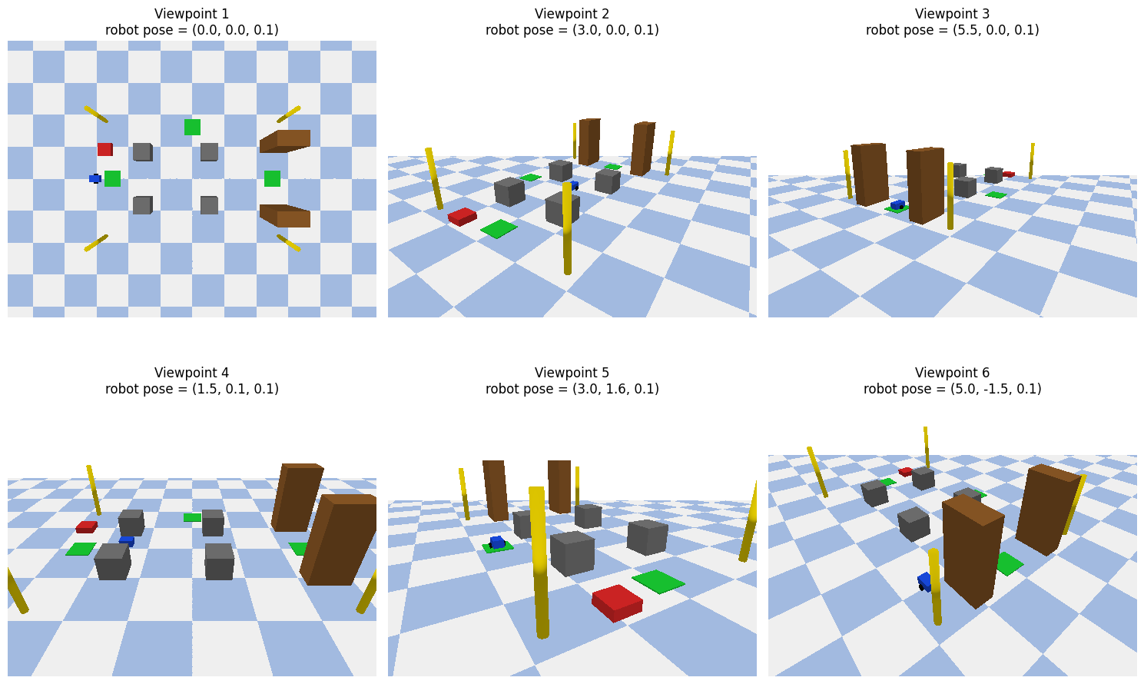
Figure 1: Six PyBullet camera viewpoints, robot repositioned between renders while all other objects remain fixed.
The interaction demonstration in cell 8 repositioned the robot to (5.5, 0.0, 0.1), close to the drop-off target, and exercised all three helper functions. print_object_roles reproduced the full fourteen-row registry in Table 1. get_objects_by_role("obstacle") correctly returned the four crate obstacles (ids 1 to 4), and get_objects_by_role("shelf") returned the two shelves (ids 12 and 13). get_nearest_target correctly identified body id 7, the drop-off target at (5.50, 0.00, 0.01), as nearest, reporting a distance of 0.092 m, consistent with the robot’s near-target placement.

3.6 Evaluation and Reflection
The main challenge was keeping camera composition consistent while the robot moved. An early version computed each viewpoint’s eye and target position relative to the robot’s own pose, causing the framing to shift unpredictably and, in one configuration, letting the robot leave the frame entirely. This was resolved by fixing camera positions relative to the room’s known bounding extent and moving only the robot between renders; the viewpoint count was subsequently extended from the minimum of three to six so the semantic layer had a wider set of perspectives to be checked against. A second approach tried and rejected assigned roles by matching each object’s URDF filename with string patterns at load time; this was replaced with an explicit role argument recorded directly in the scene layout, less error-prone and auditable in one place.
A clear limitation is that semantic labels remain static metadata assigned by the designer, rather than inferred from the rendered images themselves. This suits Task 1’s brief, which asks for an interpretable, structured environment rather than a perception system, but stops short of recognising an object’s role from appearance alone. A natural next step would use a synthetic indoor dataset such as SceneNet RGB-D (McCormac et al., 2017) to train a lightweight classifier predicting role directly from the images already captured in Section 3.5. In relation to real-world robotics, the inspection room scenario maps onto genuine warehouse and precision agriculture use cases, where a platform must distinguish an obstacle to avoid from a target requiring attention and a landmark used purely for localisation (Duckett et al., 2018); misclassifying between these categories carries direct operational consequences, which is why keeping the geometry-to-role mapping explicit and auditable matters beyond the scope of the exercise itself.

Task 2: Goal-Oriented Autonomous Robot with Monitoring (ROS2)

4.1 Project Definition
The use case adopted for Task 2 is a warehouse inspection patrol robot: a TurtleBot3 that visits a closed loop of checkpoints around a warehouse bay, avoids pallet obstacles along its route, accepts simple operator commands, and reports on its own performance. This scenario was chosen because it exercises every capability the brief asks for, goal-oriented navigation, obstacle avoidance, human-robot interaction and self-monitoring, within one coherent mission rather than as disconnected demonstrations.
The package, semantic_nav_monitor, targets TheConstruct.ai running ROS2 Humble with Gazebo Classic and the standard TurtleBot3 stack, the platform the brief specifies. Development and the evidence in this section were carried out directly on TheConstruct.ai’s browser-based ROSject platform, inside Rosject XctZpczWOA (URL identifier 1051220, app.theconstruct.ai/desktop/rosject/1051220), workspace ros2_ws. The free tier does not issue a permanent shareable URL, so the project was instead made public under its title, XctZpczWOA, which is the unique identifier required by the brief. Alongside this, an equivalent local Ubuntu 24.04 workspace running ROS2 Jazzy and Gazebo Harmonic (ros_gz_sim) was used optionally, purely to exercise GUI features that are easier to inspect outside the Rosject browser window, specifically the native LIDAR ray visualisation, the raw camera feed panel, and the planned-path line toggle; the package therefore ships a second, Harmonic-compatible launch file and world for that purpose, but it is a supplementary verification aid rather than the submission platform.
The custom Gazebo world, warehouse_inspection (built as both a Classic .world for TheConstruct.ai and a Harmonic .sdf for local verification), defines a walled rectangular bay containing eight pallet-stack obstacles (two per patrol leg) plus three smaller centreline pylons, four coloured checkpoint markers (one doubling as the charging dock), and no reliance on remote model assets. The robot model is a TurtleBot3 Burger fitted with a forward camera (burger_cam), equipped with a 360-degree LIDAR publishing /scan and wheel odometry publishing /odom.

4.2 Design and Implementation
The package contains four ROS2 nodes, summarised in Table 2. mission_controller is the only node that commands the robot; monitor_node is a purely passive observer; keyboard_hri_node provides single-keypress human interaction without requiring the Enter key; and path_visualizer_node draws the planned route inside the Gazebo client as a visual aid, with no effect on the robot’s actual behaviour.
[NEED TO CREATE AND ADD A FLOWCHAT/ARCHETECTURE DIAGRAM]
Table 2: ROS2 node architecture.
Node | Subscribes | Publishes | Role
mission_controller | /scan, /odom, /hri_command | /cmd_vel, /mission_state, /planned_path | Six-state FSM: navigation, obstacle avoidance, replanning
monitor_node | /mission_state, /odom | (console log only) | Logs transitions; computes time-per-state, distance, obstacle count
keyboard_hri_node | terminal keypresses | /hri_command, /show_planned_path | Single-key HRI: s start, p pause, x stop, v toggle path, q quit
path_visualizer_node | /planned_path, /show_planned_path | spawns/removes Gazebo line entities | Draws or hides the planned route in the Gazebo client
mission_controller implements six states rather than the assignment’s minimum of five, adding a Planning state ahead of Navigate. Table 3 sets out each state’s trigger and behaviour, matching the MissionState enum in the code exactly.
Table 3: Finite state machine (six states).
State | Entered when | Behaviour
IDLE | At launch, or after a stop/abort | Stationary, waiting for a start command
PLANNING | start received | Builds the four-checkpoint route as a nav_msgs/Path, publishes it once, then hands off immediately
NAVIGATE | After planning, or once an obstacle is cleared | Proportional controller drives towards the next checkpoint
AVOID_OBSTACLE | Forward clearance below 0.32 m for three consecutive control cycles, or an odometry-based stall | Reverses briefly (REVERSE), then rotates to a LIDAR-probed clear heading (ORIENT)
REPLAN | A clear heading has been reached | Drives forward roughly 0.45 m along that heading (COMMIT) before resuming Navigate
MISSION_COMPLETE | All four checkpoints visited, or stop received | Robot halts; final state published
Two design decisions reflect real engineering trade-offs. First, velocity commands are published as TwistStamped rather than plain Twist, since the ros_gz_bridge instance the TurtleBot3 launch infrastructure starts expects a stamped message; the unstamped type would leave the bridge silently unconnected. Second, obstacle avoidance is a three-phase sub-procedure (REVERSE, ORIENT, COMMIT): the robot probes escape headings at eleven angles per side via LIDAR, scores them by goal alignment and clearance, and commits only to one clearing a runway just above its own half-width (0.11 m) plus a small margin (0.05 m). An odometry-based stall check runs alongside: under 0.05 m of displacement after one second of commanded forward motion is treated as blocked regardless of LIDAR. After ten failed avoidance attempts, the mission aborts safely to IDLE.
monitor_node subscribes to /mission_state and /odom. On every state change it logs the transition with a timestamp, accumulates time in the previous state, and, specifically on entering AVOID_OBSTACLE, increments an obstacle-encounter counter, which the code’s own documentation records as standing in for the assignment’s “collisions” metric, since the robot avoids contact rather than colliding. Odometry feeds a running distance-travelled total, and a five-second timer prints a running summary throughout the mission. path_visualizer_node listens on /planned_path and, once told to show it, spawns thin static box entities along the route via the same Gazebo EntityFactory service used to spawn the robot; the line toggles from the keyboard (‘v’) or a native GUI panel, without altering the plan.

4.3 Execution and Testing
The package was built inside the Rosject with colcon build --packages-select semantic_nav_monitor, sourced, and launched after setting TURTLEBOT3_MODEL=burger_cam. Figure 2 shows the Rosject’s three-pane workspace: the file explorer confirming the Rosject name XctZpczWOA, mission_controller.py in the code editor, the Simulation panel with the warehouse world, robot, eight pallets and four checkpoints, and a shell streaming monitor_node’s summary, confirming platform, code and a live run together.
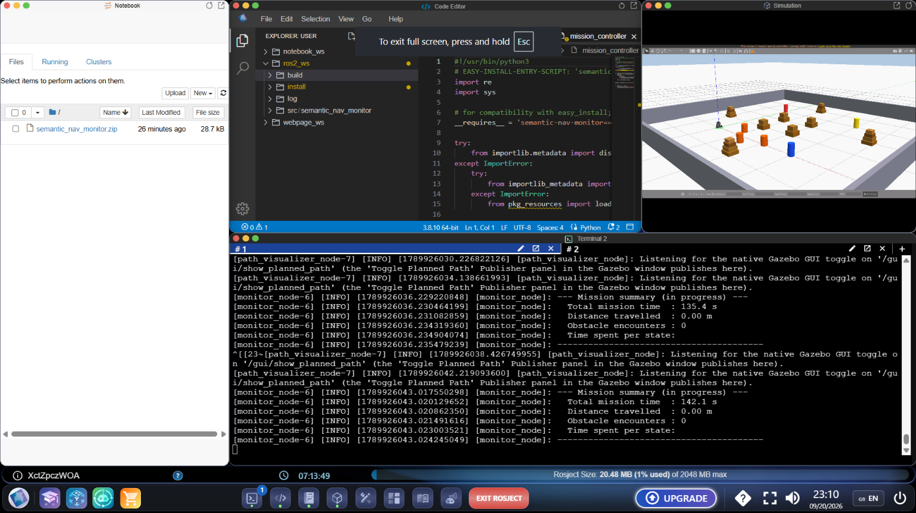
Figure 2: TheConstruct.ai Rosject XctZpczWOA: file explorer, mission_controller.py in the code editor, the live Simulation panel, and monitor_node’s summary stream in the shell.
Figure 3 shows the Gazebo client mid-patrol, with the robot navigating among the pallets; the status bar’s Real Time and Iterations counters (00:02:11 elapsed, 94,858 iterations) confirm a continuously running simulation, not a static load.
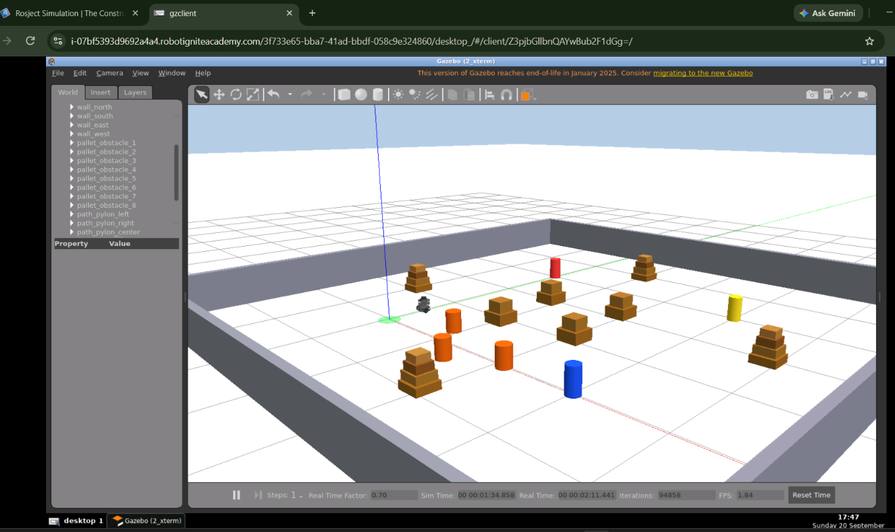
Figure 3: Gazebo client mid-patrol on TheConstruct.ai: robot among the eight pallet obstacles and checkpoint markers, with elapsed real time and iteration count visible.
Figure 4 shows keyboard_hri_node in a Rosject shell beside the live Simulation panel: s and p keypresses are echoed as Published HRI command: 'start' and 'pause', with Planned-path line: ON confirming the path toggle also responded, evidencing the human-robot interaction requirement directly.
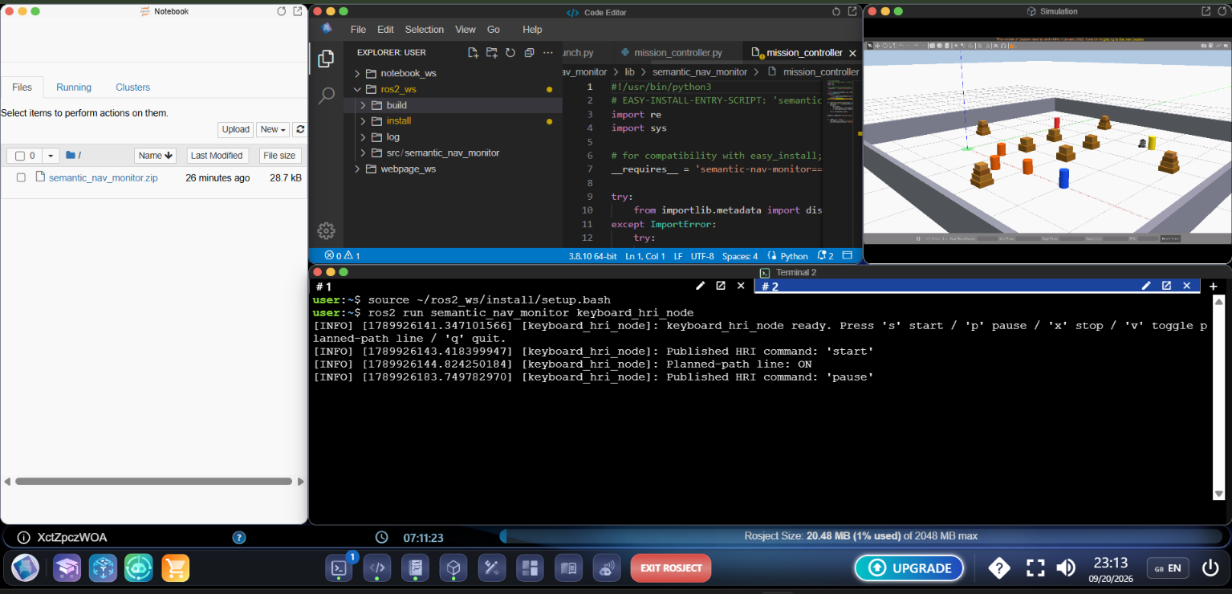
Figure 4: keyboard_hri_node in a Rosject shell: start and pause keypresses published and confirmed, alongside the live Simulation panel.
Figure 5 is a live ros2 topic echo /mission_state capture. Reading oldest to newest, it records AVOID_OBSTACLE, REPLAN, AVOID_OBSTACLE, IDLE, PLANNING, NAVIGATE and finally MISSION_COMPLETE: the robot was mid-avoidance, returned briefly to IDLE, most likely paused and restarted via the keyboard node in Figure 4, then re-planned, navigated and completed, the clearest direct evidence of a full mission carried through on the required platform.
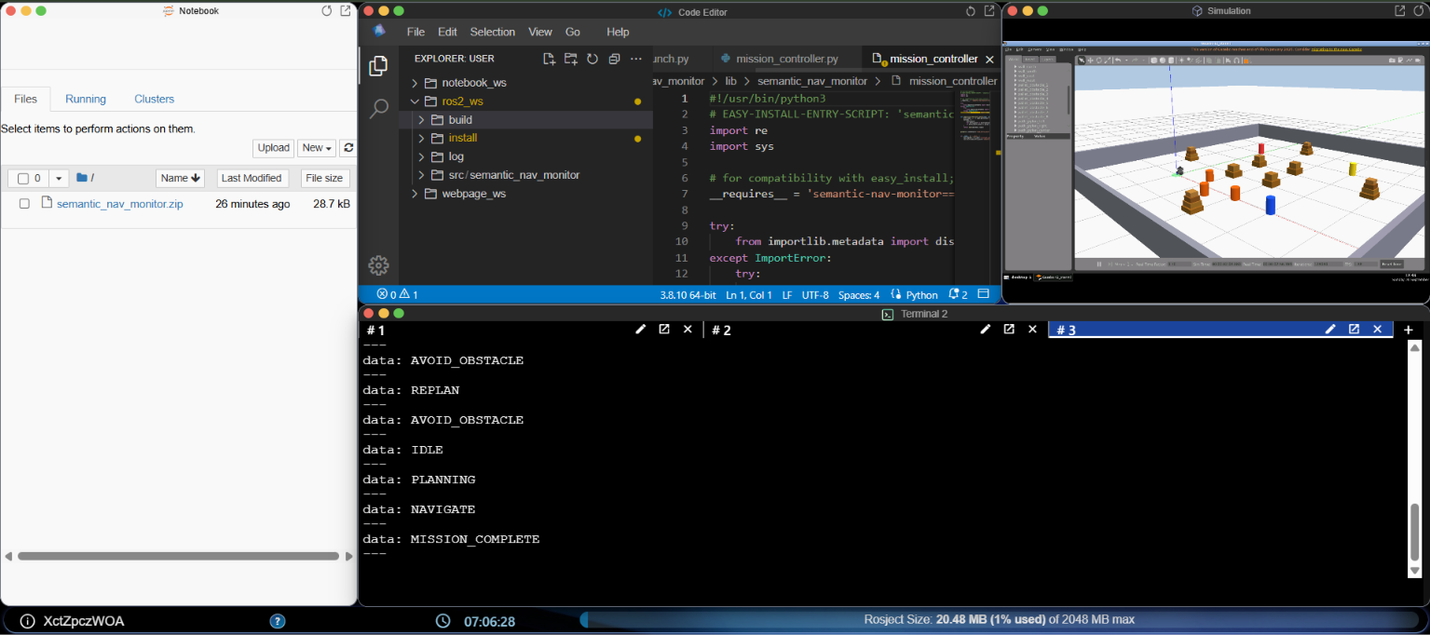
Figure 5: Live /mission_state echo showing the robot cycle through AVOID_OBSTACLE, REPLAN, IDLE, PLANNING, NAVIGATE and MISSION_COMPLETE.
Figure 6 captures monitor_node’s periodic summary shortly before that completion, reproduced in Table 4. As the header still reads “in progress” at capture, these are the last recorded progress figures rather than a separate post-completion summary, logged shortly before the MISSION_COMPLETE transition in Figure 5.
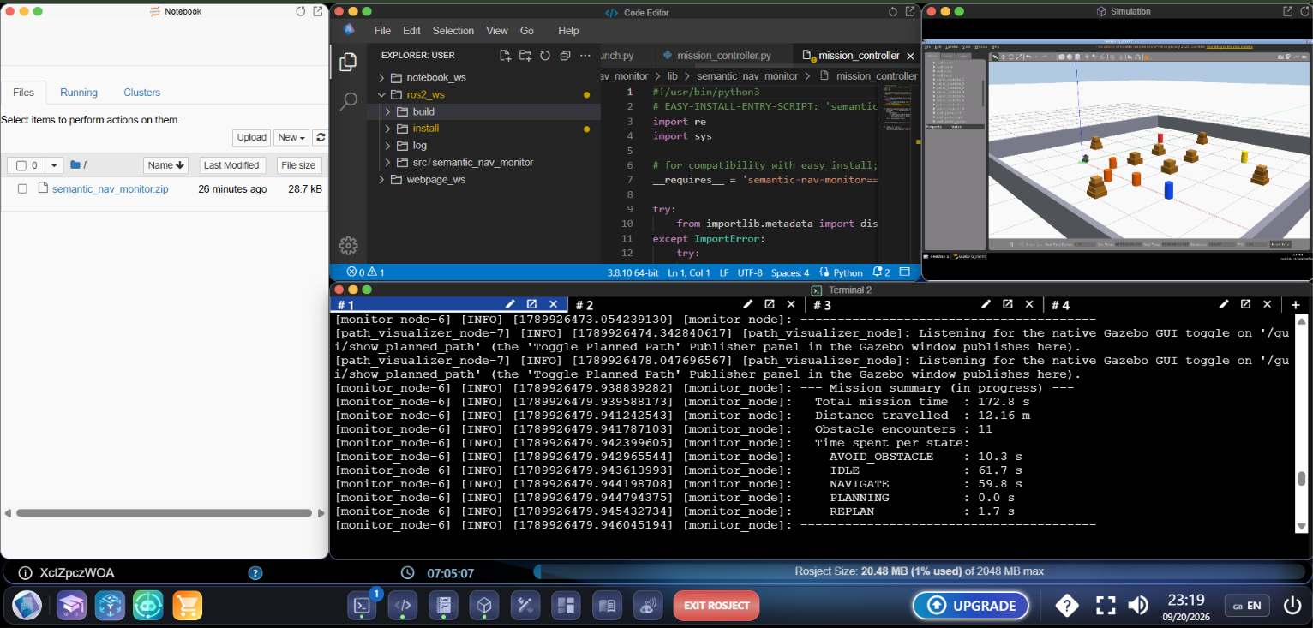
Figure 6: monitor_node’s mission summary, captured shortly before MISSION_COMPLETE.
Table 4: Mission summary logged by monitor_node on TheConstruct.ai, Rosject XctZpczWOA, shortly before MISSION_COMPLETE.
Metric | Value
Total mission time | 172.8 s
Distance travelled | 12.16 m
Obstacle encounters | 11
Time in AVOID_OBSTACLE | 10.3 s
Time in IDLE | 61.7 s
Time in NAVIGATE | 59.8 s
Time in PLANNING | 0.0 s
Time in REPLAN | 1.7 s
The local Jazzy/Harmonic workspace supplied one further, supplementary view not easily captured inside the Rosject browser window: Figure 7 shows native LIDAR-ray visualisation active near a pallet obstacle, with the forward camera feed in the same panel, confirming the sensing picture the AVOID_OBSTACLE logic in Section 4.2 acts on.
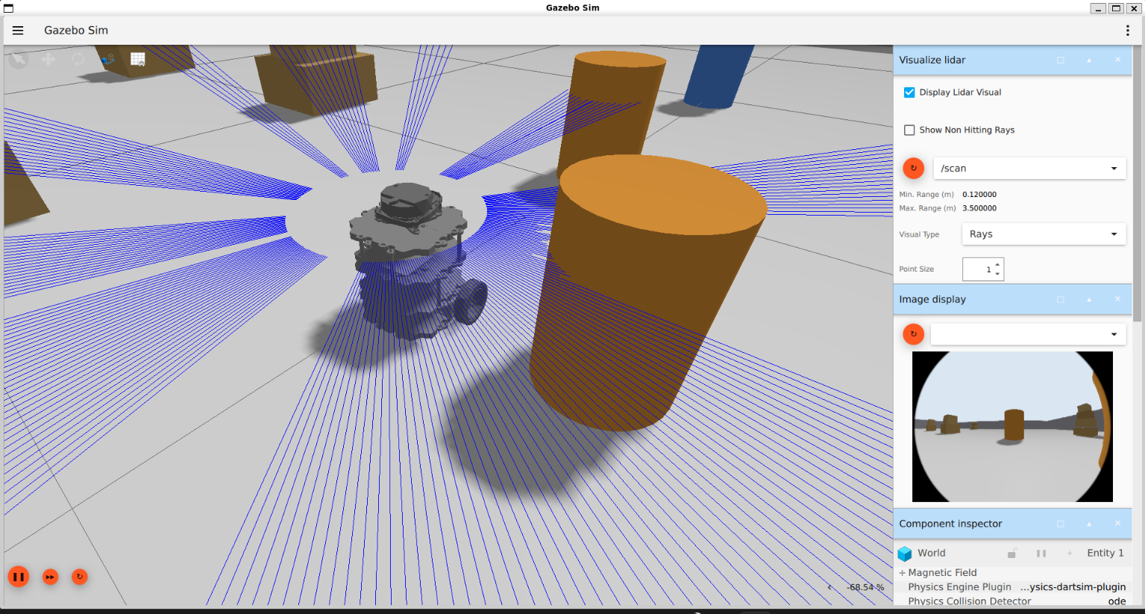
Figure 7: Local Gazebo Harmonic verification: LIDAR rays visualised around the robot near a pallet obstacle, with the forward camera feed shown alongside.
Five test cases are directly evidenced on the required platform: Rosject identity and a live simulation (Figure 2); a continuously running world (Figure 3); keyboard HRI with confirmed acknowledgement (Figure 4); a complete state cycle reaching MISSION_COMPLETE (Figure 5); and logged mission metrics (Figure 6, Table 4). LIDAR sensing is additionally evidenced locally (Figure 7).

4.4 Evaluation and Reflection
Table 4 is informative about a limitation met during development: eleven obstacle encounters against 12.16 m travelled, with 61.7 s in IDLE, points to a mission that included at least one operator pause and restart, consistent with Figure 5. Several rounds of tuning were needed: the required escape-heading clearance was originally set well above the robot’s actual half-width, causing unnecessary detours around gaps it could physically fit through; and an earlier scoring rule always picked the heading most aligned with the goal even at bare-minimum clearance, causing an oscillation where the robot hugged one edge of a gap, stalled, and retried on the other side. Both were corrected, by trimming margins closer to the real 0.11 m half-width and preferring, among similarly aligned headings, whichever offered more open space; only 10.3 s was ultimately spent in AVOID_OBSTACLE against 59.8 s in NAVIGATE, a marked improvement on earlier local trials where avoidance dominated.
A second limitation is the REPLAN state’s simplicity: it drives forward along a probed-clear heading for a fixed distance rather than computing a genuine path around the obstacle’s full extent. A local costmap-based planner, as used within the Nav2 navigation stack (Macenski et al., 2020), would route around extended obstacles more efficiently than this probe-and-commit approach, at the cost of considerably more implementation complexity. A third, procedural limitation is that TheConstruct.ai’s free tier issues no permanent shareable simulation URL, so the Rosject is shared by its unique name, XctZpczWOA, a platform constraint rather than a shortcoming of the package.
Despite these limitations, the underlying approach, a small number of explicit states, reactive obstacle handling backed by a redundant odometry check, and continuous self-reporting, maps directly onto real warehouse and service robotics, where operational staff generally need to understand why a robot took a particular action rather than trust an opaque policy (Siegwart, Nourbakhsh and Scaramuzza, 2011). The obstacle-encounter count and per-state timing in Table 4, logged on the platform the brief specifies and culminating in a genuine MISSION_COMPLETE transition, are exactly the kind of evidence a site operator would want before trusting a patrol robot in a live warehouse.

Combined Evaluation and Reflection
Together, the two tasks address complementary halves of the same question: how a robotic system represents and acts on the meaning of what is around it. Task 1 demonstrates semantic representation in a static, fully observable scene, where roles are assigned by the designer and retrieved through dictionary lookups; the fourteen-row registry in Table 1 and the sub-tenth-of-a-metre nearest-target result in Section 3.5 show that lookup working correctly. Task 2 demonstrates semantically informed behaviour in a dynamic setting, where the robot reacts to LIDAR and odometry in real time and selects among six states whose meaning, avoiding, replanning, completing, is a label it applies to its own behaviour rather than an external object.
Working through both tasks reinforced that simulation, perception, navigation and monitoring are stages of one pipeline rather than separate concerns. The camera-based observation in Task 1 and the LIDAR-based sensing in Task 2 both feed a decision layer, whether query functions or a finite state machine, and both benefit from an explicit monitoring mechanism, print_object_roles and monitor_node respectively, that lets internal reasoning be inspected rather than treated as a black box. The most instructive moment was arguably a documented failure rather than a success: the over-cautious obstacle avoidance in Task 2, corrected across several rounds of threshold tuning, shows a system can be technically correct, avoiding every obstacle, while still being a poor design that wastes most of its time doing so, and that catching this required the monitoring layer itself.

Concluding Remarks
This report has documented two exercises for the Robotics Software and Programming module: a PyBullet simulation with object-level semantics stored as static metadata and queried through helper functions, and a ROS2 goal-oriented navigation system for a TurtleBot3 with a six-state machine, LIDAR and odometry based obstacle avoidance, keyboard HRI, and continuous self-monitoring. Both were implemented and executed against the requirements in the brief, and the evidence presented, a six-viewpoint render set and a full object registry for a publicly hosted Task 1 notebook, and Rosject, world, HRI, state-cycle and mission-metric screenshots captured directly on TheConstruct.ai for Task 2, is drawn from what each system actually produced rather than from an idealised description of what it was meant to do. Task 2 was run to a genuine MISSION_COMPLETE on the required platform, inside Rosject XctZpczWOA. The remaining outstanding item is procedural rather than technical: a cold-start confirmation of the Task 1 notebook running inside Colab itself, listed below. The clearest shared lesson is that semantic structure, whether encoded as metadata attached to objects or expressed through a robot’s own behavioural states, only becomes trustworthy once it is monitored and logged, not merely implemented.

Acknowledgement
Perplexity AI (2026) was used to support literature searching, identify potentially relevant academic sources, and assist with grammar correction and word-limit reduction during editing. All sources included in the reference list were checked by the author and cited as the original academic works rather than citing Perplexity AI as a source. The analysis, interpretation, discussion, and final written content submitted in this report are the author’s own work and responsibility.
The architecture and pipeline diagrams in Sections 3.3 and 4.2 (REPLACE WITH PROPER SECTIONS) were generated using Python scripts with the matplotlib library, written specifically to render the structures described in this report. The scripts and their outputs were reviewed by the author before inclusion.

References
Coumans, E. and Bai, Y. (2021) PyBullet, a Python Module for Physics Simulation for Games, Robotics and Machine Learning. [online] Available from https://github.com/bulletphysics/bullet3 [Accessed 20 September 2026]
Duckett, T., Pearson, S., Blackmore, S. and Grieve, B. (2018) Agricultural Robotics: The Future of Robotic Agriculture. UK-RAS White Papers. [online] Available from https://arxiv.org/abs/1806.06762 [Accessed 20 September 2026]
Macenski, S., Martin, F., White, R. and Gines Clavero, J. (2020) ‘The Marathon 2: A Navigation System.’ In: Proceedings of the IEEE/RSJ International Conference on Intelligent Robots and Systems (IROS). Las Vegas, 24-30 October 2020: 2718-2725
McCormac, J., Handa, A., Leutenegger, S. and Davison, A.J. (2017) ‘SceneNet RGB-D: Can 5M Synthetic Images Beat Generic ImageNet Pre-training on Indoor Segmentation?’ In: Proceedings of the IEEE International Conference on Computer Vision (ICCV). Venice, 22-29 October 2017: 2678-2687
Open-Source Robotics Foundation (2024) ROS 2 Documentation: Humble. [online] Available from https://docs.ros.org/en/humble/index.html [Accessed 20 September 2026]
Open Robotics (2024) Gazebo Harmonic Documentation. [online] Available from https://gazebosim.org/docs/harmonic [Accessed 20 September 2026]
PyBullet (2023) PyBullet Quickstart Guide. [online] Available from https://pybullet.org/wordpress/ [Accessed 20 September 2026]
Quigley, M., Gerkey, B. and Smart, W.D. (2015) Programming Robots with ROS: A Practical Introduction to the Robot Operating System. Sebastopol, CA: O’Reilly Media
ROBOTIS (2023) TurtleBot3 e-Manual. [online] Available from https://emanual.robotis.com/docs/en/platform/turtlebot3/overview/ [Accessed 20 September 2026]
Siegwart, R., Nourbakhsh, I.R. and Scaramuzza, D. (2011) Introduction to Autonomous Mobile Robots. 2nd ed. Cambridge, MA: MIT Press
TheConstruct (2023) ROS2 Basics in 5 Days (Python). [online] Available from https://www.theconstruct.ai/ [Accessed 20 September 2026]

